想法 sum(set(list)) \*2 – sum => single number

class Solution:

def singleNumber(self, nums: List[int]) -> int:

return (2\*sum(set(nums)) - sum(nums))

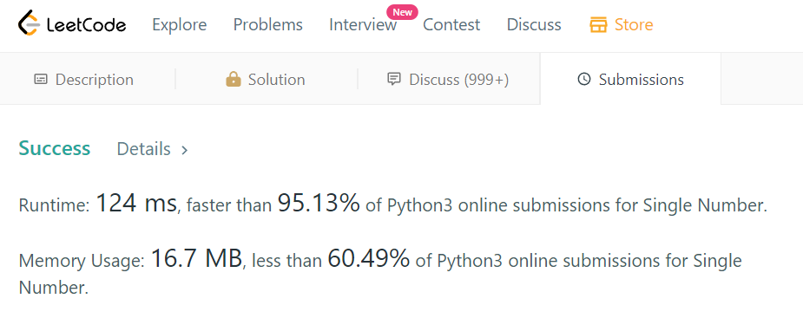

Others:

def singleNumber1(self, nums):

dic = {}

for num in nums:

dic[num] = dic.get(num, 0)+1

for key, val in dic.items():

if val == 1:

return key

def singleNumber2(self, nums):

res = 0

for num in nums:

res ^= num

return res

def singleNumber3(self, nums):

return 2\*sum(set(nums))-sum(nums)

def singleNumber4(self, nums):

return reduce(lambda x, y: x ^ y, nums)

def singleNumber(self, nums):

return reduce(operator.xor, nums)